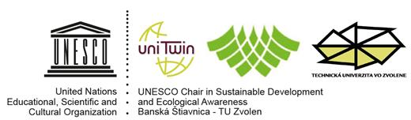
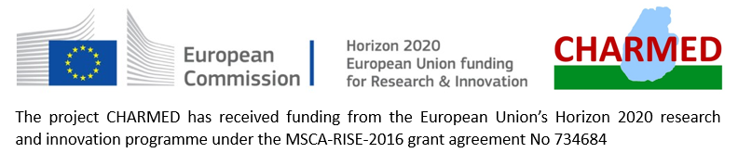
Magyar Professzorok Nemzetközi Szövetsége
International Association of Hungarian Professors
Association Internationale des Professeurs Hongrois d’Université
)

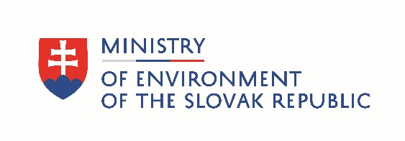
and Slovak Commission for UNESCO

7th International Conference
under the auspice of the Ministry of Environment of SR

Selected Aspects of Integrated Environmental Management:
„Culture and Environment“

Zvolen
10th – 11th October, 2019

Slovak Commission for UNESCO
UNESCO-Chair for Ecological Awareness and Sustainable Development
of Faculty of Ecology and Environmental Sciences, Technical University in Zvolen
in cooperation with
Global Water Partnership Slovakia
Project Charmed, Horizon 2020 – MSCA –RISE – 2016, No 734684
International Association of Hungarian Professors
under the auspices of
Ministry of the Environment of Slovak Republic

kindly invite you to the

7th International Conference
Selected Aspects of Integrated Environmental Management
„Culture and Environment“

International conference takes place at occasion of 25th anniversary of the UNESCO Department for Ecological Awareness and Sustainable Development

Scientific committee:
Dr.h.c. prof. RNDr. László Miklós, DrSc.
RNDr. Tomáš Orfánus, PhD.

Organizational committee:
Mgr. Zlata Androvičová, CSc. (androvicova@tuzvo.sk), doc. Ingrid Belčáková, PhD. (belcakova@tuzvo.sk), Ing. Andrea Diviaková, PhD. (diviakova@tuzvo.sk), Mgr. Attila Rácz, PhD. (racz@tuzvo.sk), Miroslava Ružinská (ruzinska@tuzvo.sk)

The scientific objectives of the conference are based on the central theme "Culture and Environment". The conference will include following topics:

I. BLOCK - Approaches to integrated environmental managementꓼ

II. BLOCK - Culture of thinking, behavior, decision-making and environmental management: ecological, environmental, economic, technical, political-legal, philosophical, ethical, psychological and educational aspectsꓼ

Target group:
scientific and professional public, non-governmental organizations, governmental authorities, self-government, environmental stakeholders, action groups in landscape planning, landscape management and tourism

Venue and date: Technical University in Zvolen, October 10 – 11, 2019
Conference language: Slovak, Czech, English
Registration submission deadline: August 23, 2019
Paper submission deadline: Septembre 30, 2019
Contact: androvicova@tuzvo.sk, ruzinska@tuzvo.sk,
Phone: +421-45/5206563, +421-45/5206818, +421-908/329372
Conference fee: 50 €/students 20 € (including conference costs, proceedings, refreshment, excursion)
Conference fee deadline: August 31, 2019
Accommodation and meal should be covered by participants. In case of your interest, the organizing committee is happy to help you with accommodation and meal booking at Bariny student residence (15 € /night).

Provider of services:

UNIVERZITNÁ VEDECKOTECHNICKÁ SPOLOČNOSŤ TECHNICKÁ UNIVERZITA VO ZVOLENE

T.G.Masaryka 24, 960 53 ZVOLEN, č.t. 045/5206281

Account name: Univerzitná vedeckotechnická spoločnosť Technická univerzita Zvolen

Bank: SLSP, a.s. Zvolen

Account No. IBAN: SK5709000000000071635417

BIC-SWIFT Code: GIBASKBX

Variable symbol: 908/19

IČO: 35986433; DIČ: 2021433425

Information for receiver: your name

Conference Draft Programme

10.10. 2019 - Congress center of Technical University of Zvolen – scientific part
11.10.2019 - Congress hall in Kammerhof, Banská Štiavnica, city of a culture 2019 – official
part

The event will include a excursion of participants in the World Cultural and Natural Heritage Region UNESCO Banská Štiavnica.

October 10, 2019

9⁰⁰ – 10⁰⁰ Registration
10⁰⁰ – 10¹⁵ Conference welcome
10¹⁵ – 12⁰⁰ TOPIC I presentations
12⁰⁰ – 13⁰⁰ Lunch
13⁰⁰ – 14⁰⁰ TOPIC I presentations - continuation
14⁰⁰ – 14³⁰ Discussion
14³⁰ – 14⁴⁵ Break, refreshment
14⁴⁵ – 16¹⁵ TOPIC II presentations
16¹⁵ – 16³⁰ Break, refreshment
16³⁰ – 17³⁰ TOPIC II presentations – continuation
17³⁰ – 18⁰⁰ Discussion
18⁰⁰ – 18³⁰ Poster presentation

October 11, 2019

8⁰⁰ – 8¹⁵ Bus departure from the yard of the Technical University
8¹⁵ – 9⁰⁰ Transfer to Banská Štiavnica
9¹⁵ – 11⁰⁰ Conference hall Kammerhof - Ceremonial part of the conference to the anniversary of the founding of the UNESCO Department
11⁰⁰ – 12³⁰ Reception (rout)
13⁰⁰ – 15⁰⁰ Field excursion: „Tajchy (artificial water reservoirs) of Banská Štiavnica“
15⁰⁰ – 16⁰⁰ Return by bus to Zvolen

Registration Form

7th International Scientific Conference Selected Aspects of Integrated Environmental Management: „Culture and Environment“

Zvolen
10-11 October, 2019

1. Last name:
2. First name
3. Professional title
4. Institution

5. Position

6. Title of paper

7. Key words (max 5)
7. Title of poster

8. Postal address

9. E-mail
10. Phone
11. Accomodation in student residence Bariny | 9.10. - 10.10.  Yes/No | 10.10. - 11.10.  Yes/No | 11.10. -12.10.  Yes/No | 12.10. - 13.10.  Yes/No
12. Lunch in student residence Bariny | 10.10.2019  Yes/No
13. Vegetarian food | Yes/No
14. Field excursion | 11.10.2019 afternoon  Yes/No
Search for Hotel Facilities in Zvolen: www.ubytovanienaslovensku.eu , www.trivago.sk

Contributions will be published as chapters in monograph. Instructions for authors will be sent in the exact conference program by 13. 09. 2019.
Programme will be modified according to applied papers and participants interests for an excursion.

Contact: androvicova@tuzvo.sk (+421-45/5206818, +421-908/329372), ruzinska@tuzvo.sk (+421-45/5206563)

